Spring Term 2020 Newsletter

- Autumn Term Fundraising
Thank you to everyone for your support! We raised £217.75 for Children in Need from our tabletop sale and Christmas show.

- Toothbrushing programme
Our tooth brushing programme continues. Please remember to send in £10.00 for your child’s toothbrushes for the year if you haven’t already. Have a go at the sugar quiz at the end of this newsletter.

- Staff training
All staff have had training with the charity Vista on the use of activities to support the basic assessment of children’s eyesight.
Laura and Gemma will be renewing their First Aid Certificates. All staff have a first aid certificate.
There will be specific training on Early Talk this term to support children’s speech and language.
Laura has also attended the Healthy Tots network meeting -take the quiz at the end of this newsletter to test your knowledge.

- Planning for chatterbox activities for the Spring Term
Our chatterbox activities complement the termly topics we cover in the setting. You can find the chatterbox activities displayed on the front door and posted weekly to our Facebook page. Chatterbox activities are a fun way of engaging with your child and promoting speech and communication both at home and nursery. We encourage all parents to do the weekly activities with their children. They encourage children to develop confidence, self-esteem and a growing vocabulary. Vocabulary at age 5 is a powerful predictor of attainment at GCSE.
In feedback, parents who have done the chatterbox activities over the years with their children have said how much they enjoyed the time spent working on an activity with their child. For new parents who have joined us, you will need to decorate a shoebox with your child, clearly labelling it with their name. Please send it in with your child each week with the completed task of the week inside. If we ask for photos as part of an activity, you can upload these via Tapestry.

- Tapestry
We actively encourage you to upload your photos and comments to us through Tapestry. We love to hear what your children have been doing at home! Photos and observations of your child at nursery can be shared with your child, please check Tapestry every fortnight.
If you have any questions about tapestry let us know.

- 20th Anniversary!
It was our 20th anniversary on the 20th January this year. We are planning to celebrate our 20th birthday with a celebration, date to be confirmed.
If you would like to help in planning an event to mark the celebrations, please speak to Laura/Helen. We would like to invite all families and staff who have been a part of our nursery since January 2000 to celebrate with us.
Nursery News
Children’s clothes
Please ensure that you consider the weather when bringing your child to nursery and ensure that they are dressed appropriately. Children should come with hats and gloves and suitable footwear. All children should have a bag of spare clothes at nursery, and nappies etc. if still in nappies. Could we please ask you to also label all of your children’s clothes and bags. For ease in the cloakroom drawstring bags are easier to hang up and can be purchased from nursery for £1.50.
Absences
Please ensure that you ring the nursery if your child is absent and send in an absence note on their return. This is a requirement of funding.

Planning for the Spring Term

- January to February half term – All about food!
Chatterbox activities to support this topic have been displayed on the front door.
What have we done so far?
The first half of the term focused on the areas of learning:’ Mathematics’ and ‘Understanding the World’. Here is Gemma’s summary as the lead for the first half term, and photo of some of the children’s work:
This half term we have used the following story books as an introduction to the children to learn about vegetables and fruits, through talking about them, tasting them and cooking with them.
‘Handa’s Surprise’
‘I will never ever eat a tomato’
My first Chinese new Year!
‘The Enormous Turnip’
We made a lovely butternut squash soup and a Chinese vegetable stir fry with rice noodles that all the children tried and most of them enjoyed! Thank you to all of you for sending in the wonderful fruits and vegetables, which we used.
We also learnt about helping people who aren’t able to buy foods to feed their families by collecting foods for the food bank. Once again thank you for your donations which are being donated to the Jubilee Food Bank.

- February to Easter
During the second half of this term, we are focusing on the areas of learning ‘Communication and Language’ and ‘Expressive Arts and Design’. Please remember to send in your child’s chatterbox with the activities that you’ve done at home with them.

Upcoming events
- World Book Day Thursday 5th March
Share a story session
- Tuesday 3rd March 11.15am -11.45am
- Wednesday 11th March 11.15- 11.45am
- Thursday 19th March 11.40am-11.55 am
- Friday 27th March 11.40am – 11.55am
- Visit to the allotments Friday 20th March
- Easter Bonnet parade Wednesday 1st April
- Talk Boost workshop for parents 26th March 9.15-10.00
- Parent workshop -school readiness 2nd April 9.15-10.00

Easter Bonnet parade
Decorate an Easter bonnet at home and bring in on Thursday 1st April. If your child doesn’t usually attend on a Wednesday but would like to take part, please bring your child in at 11.35am for the parade after which you can take them home. If any parents would like to attend please arrive at 11.35am.
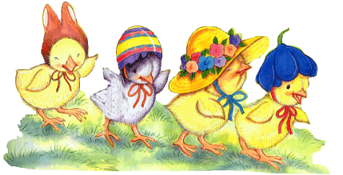

Term dates 2019/2020
Spring Term 2020
Tuesday 7 January | Start of Term - Nursery opens
17 to 21 February | Half Term
Fri 3 April | End of Term - Nursery closes for Easter
Summer Term 2020
Mon 20 April | Start of Term - Nursery opens
Friday 8 May | VE DAY Anniversary Bank Holiday
25 May to 29 May | Half Term
Fri 10 July | End of Term - Nursery closes for Summer

Sugar Quiz

Can you place the correct quantity of sugar, below each of these drinks from the list below? See the parent board for answers.
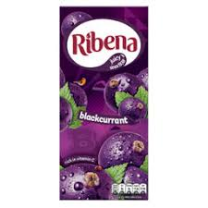
This Photo by Unknown Author is licensed under CC BY-SA

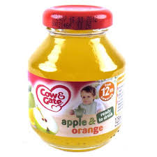

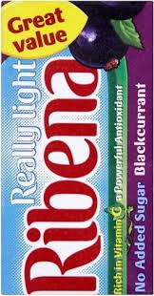

52.5g | 29g | 39g | 22g | 21.6g | 21g | 10.1g
8.3g | 0.8g | 0g

