

**Summer Term 2019 Newsletter**

Dear parents and carers,

We will soon be saying goodbye to our children and families moving onto school, now the 19th group of graduates since our nursery first opened! For those of you that are leaving us please pick up a transition to school suggestion handout on how you can support your child to make a smooth transition to school. For those of you staying on with us next term, please let us know of any changes to the session hours wanted for your child from September. A huge thank-you to all parents who have volunteered their time this year supporting us with our topics and events. We hope everyone has enjoyed our last term and has a happy summer holiday!

**Nursery News**

**E-learning journeys**

**For parents whose children are going on to school, please ensure that you download the learning journey for your child to print off to keep, as your child’s data will be deleted during the summer holiday.** Please keep checking and adding your comments to tapestry. If you wish we can make up a PDF of your child’s learning journey. There will be a £5.00 charge for this. Next term we will be encouraging more frequent use of the platform by parents so that you can stay updated on your child’s progress.

**Planning for June/July**

For chatterbox activities please see notice on door

**Staff news**

We have had a bit of a staff restructure as Lisa has reduced her hours. We are looking to appoint a part time early years practitioner to start in September.

**Tooth brushing programme**

Our tooth brushing programme has been going really well and is now part of our regular routine. Unfortunately although we have asked parents to contribute on a half termly basis for a new toothbrush only a few have. From next term we will be invoicing all parents for the year. The cost for new toothbrushes for the year will be £10.00/child. Our toothbrush holders which are used to store the toothbrushes only take a certain size of toothbrush, which is why we’re asking you to purchase them from us rather than bringing/buying your own. We will be having a dentist visit in September to talk to the children about oral health and would like to invite parents to come along to the session as well.

**Parent information sessions**

We will be doing Information sessions for parents which will take place from September 2019 on the following, look out for dates during the start of next term

* Supporting speech and language
* Encouraging positive behaviour
* Healthy eating/toothbrushing

|  |
| --- |
| **Nursery Fees**  As of July there will be an increase to nursery fees:  9.00am – 12.00noon- (Morning session)  £18.75(3-5yrs non funded) £19.50 (2-3yrs) £20.25 (9mnths – 2yrs)  12.00noon – 1.00pm – (Lunch Club) £6.25 (children are required to bring a healthy packed lunch. Please ask for advice sheet, hot meals can be ordered at an extra cost) £6.50 (2-3yrs) £6.75 9mnths-2yrs  P.S. Please could we ask all parents to remove all belongings from the cloakroom by the end of term. Any unclaimed items will be donated to charity. |

**Planning for the first half of the Summer Term**

**Topic – Big Voices & Little Feet (a music and movement topic)**

For this topic, we’ll be exploring sounds, movement and music through nursery rhymes, listening to different genres of music, and making music ourselves.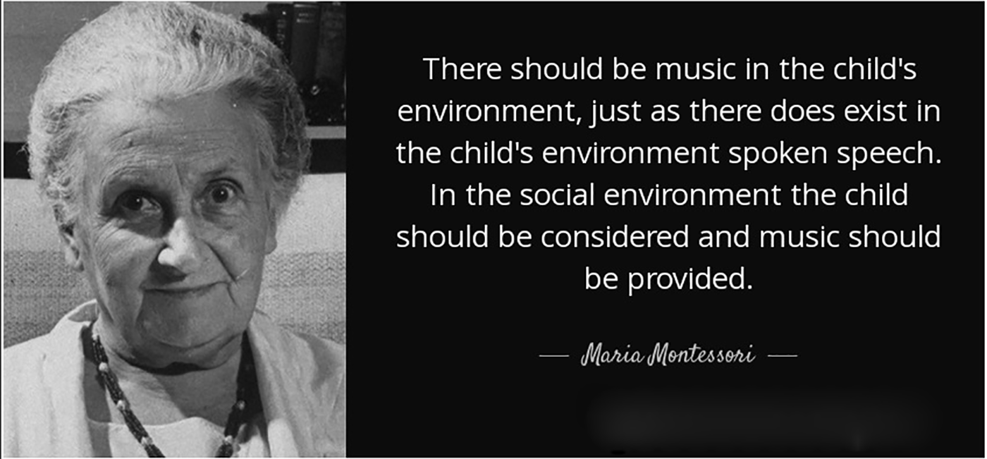

Chatterbox activities to support this topic have been displayed on the parent board and on our Facebook page weekly.

Music and movement are instruments of learning and development. It really is as simple as turning on the radio or tapping your toes. When a young child listens to music, plays a musical instrument or even dances, lots of things start happening. The brain starts forming connections that pave the way for learning opportunities such as vocabulary building and math comprehension. Not only that, but music can be fun.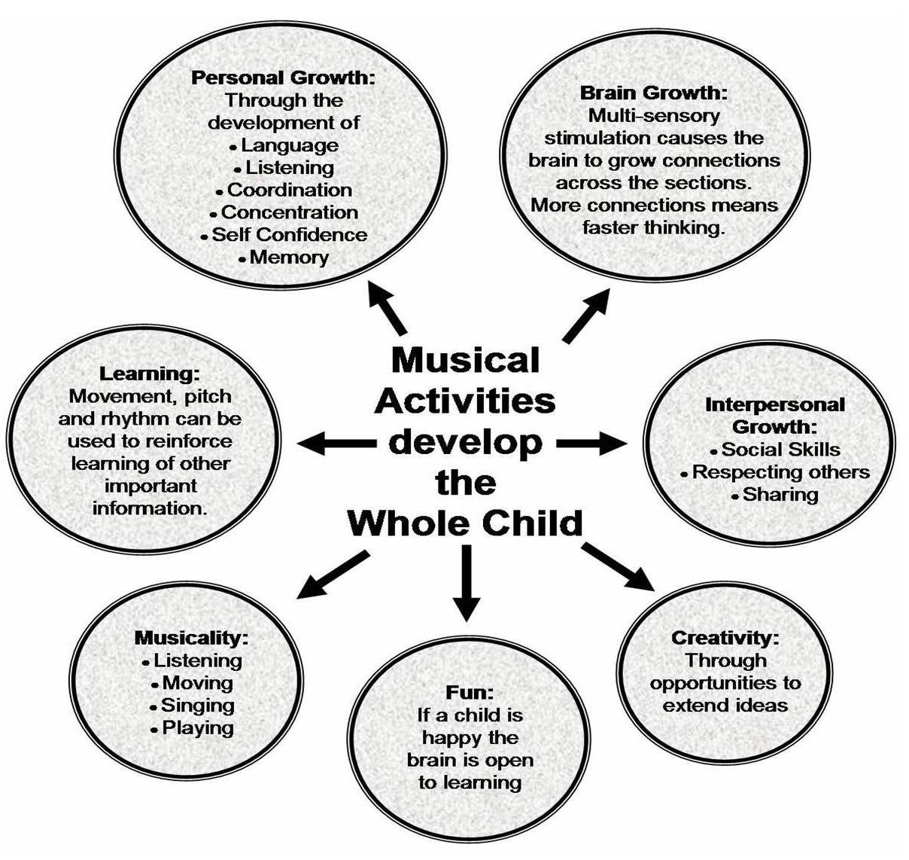 The children will be exploring the following over the next few weeks:

**1 – Nursery rhymes**

**2- Instrumental and or classical music**

**3 – Folk or cultural music and Dance**

**4 – Miscellaneous- Other kind of music: Rock, Pop, Rap, etc.**

**Summer term planning June/July**

For the last half of the summer term, we will be focusing on children’s physical development and personal, social and emotional development. The children will be preparing for sports day and for those going to school we will be focusing on transition to school.

Next term we will be hosting fundraising days to raise money to buy equipment for our outdoor area. We hope that you will support our efforts.

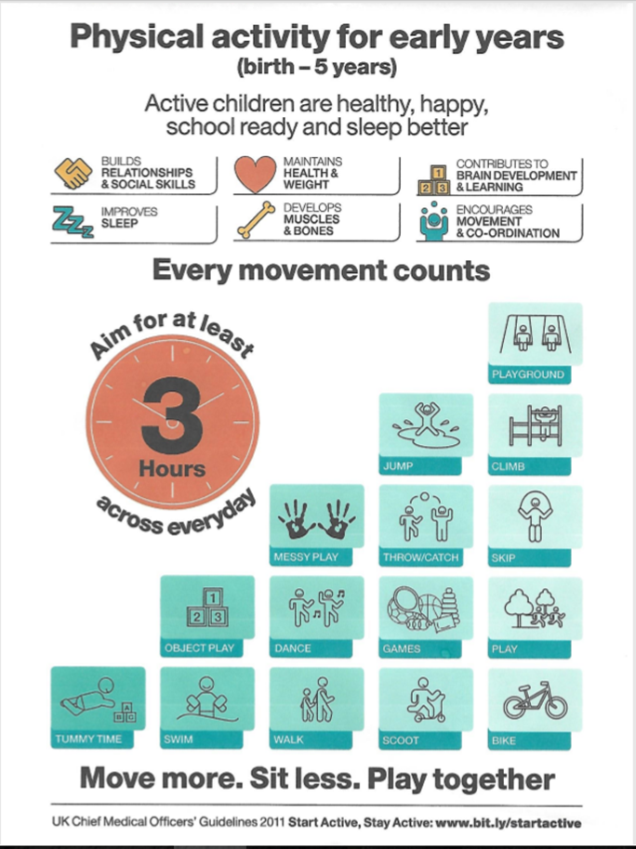

**Events**

**Father’s week 17th-21st June - see noticeboard**



**Dates for Your Diary 19/20**

|  |  |
| --- | --- |
| **Summer Term 2019** | |
| **Fri 12th July** | **End of Term - School closes for Summer** |

|  |  |
| --- | --- |
| **Autumn Term 2019** | |
| **Monday 2nd September** | Start of Term – Nursery opens |
| **14 to 18 October** | Half Term |
| **Friday 20th December at 12pm** | End of Term - Nursery closes for Christmas |
| **Spring Term 2020** | |
| **Tuesday 7 January** | Start of Term - Nursery opens |
| **17 to 21 February** | Half Term |
| **Fri 3 April** | End of Term - Nursery closes for Easter |
| **Summer Term 2020** | |
| **Mon 20 April** | Start of Term - Nursery opens |
| **Friday 8 May** | **VE DAY Anniversary Bank Holiday** |
| **25 May to 29 May** | Half Term |
| **Fri 10 July** | End of Term - Nursery closes for Summer |